Final Project Report

“Connect & Converse”: A Web-based Interactive Discussion Hub for University Students



Project Supervisor

Muhammad Saeed Amjad

Submitted By

Rubina
BC210400604

Software Projects & Research Section,
Department of Computer Sciences,
Virtual University of Pakistan


CERTIFICATE

This is to certify that Rubina (BC210400604) have worked on and completed their Software Project at Software & Research Projects Section, Department of Computer Sciences, Virtual University of Pakistan in partial fulfillment of the requirement for the degree of BS in Computer Sciences under my guidance and supervision.

In our opinion, it is satisfactory and up to the mark and therefore fulfills the requirements of BS in Computer Sciences.

Supervisor / Internal Examiner

Muhammad Saeed Amjad
Supervisor,
Software Projects & Research Section,
Department of Computer Sciences
Virtual University of Pakistan

___________________
(Signature)

External Examiner/Subject Specialist
<<External Supervisor Name>>

___________________
(Signature)

Accepted By:

_____________
(For office use)

EXORDIUM

In the name of Allah, the Compassionate, the Merciful.

Praise be to Allah, Lord of Creation,
The Compassionate, the Merciful,
King of Judgment-day!

You alone we worship, and to You alone we pray for help,
Guide us to the straight path

The path of those who You have favored,

Not of those who have incurred Your wrath,
Nor of those who have gone astray.

DEDICATION



IN THE NAME OF ALLAH THE MOST BENIFICIENT THE MERCIFUL

I dedicate this Project to my beloved
Father & Teachers
And
To the Loving memory of my Mother
And also
To my brothers & sisters.
You have successfully made me the person I am becoming
You will always be remembered.

ACKNOWLEDGEMENT

Foremost, I am highly grateful to Allah for His blessing that continue to flow into my life, and because of You, I made this through against all odds.

With a great pleasure I would like to acknowledge the support, assistances and contribution made by individuals from the beginning of the Project, providing me access, data and information, to the writing process until the completion of this project.

First of all, I want to give thanks to our project supervisors Asif Hussain for the access and assistance in order to make my project possible.

Second I would like to thank all the Mater program staff, thank you all for the assistance and constructive discussions we had during the entire courses

PREFACE

This project report has been prepared in fulfillment of the requirements for the BS in Computer Science.

For preparing of the project report, I have closely studied “Connect & Converse”: A Web-based Interactive Discussion Hub for University Students of certain compounds to get the knowledge of the data requirements that will be used successfully to protect any entrance breaches.

I have also studied the software that was required for this project coding like, PHP and databases.

This project started with to final coding I which have given me the ability to understand the concept of programming and move me forward smoothly.

I am very thankful to my supervisors who have helped me to complete this project and I really appreciate all his efforts and support.

I am also very thankful to Virtual University, Pakistan and all the staff.

TABLE OF CONTENTS

Chapter No. 1
Gathering & Analyzing Info 9

1.1 Introduction: 10
1.2 Purpose: 10
1.3 Scope of Project: 10
1.4 Definitions, Acronyms and Abbreviations 11
1.5 Project Requirements 11
1.5.1 Functional Requirements: 11
1.5.2 Non-Functional Requirements: 11
1.6 Use Cases and Usage Scenarios: 14
1.6.1 Use Case Diagram: 14
1.6.2 Usage Scenarios: 15
1.7 Development Methodology: 18
1.7.1 Chosen Methodology: 18
1.7.2 Reasons for Chosen Methodology: 18
1.7.3 Work Plan (Gantt Chart): 21
1.7.4 Project Schedule (Submission Calendar): 22

Chapter No. 2
Designing the project 23

2.1 Introduction: 24
2.2 Purpose: 24
2.3 Scope: 24
2.4 Definitions, Acronyms and Abbreviations: 24
2.5 Architectural Representation (Architecture Diagram) 24
2.6 Dynamic Model: Sequence Diagrams: 26
2.7 Object Model/Logical Model: Class Diagram: 31
2.8 Database Model (Database Diagram): 31
2.9 Graphical User Interfaces: 32

Chapter 3
Development 35

3.1 Development plan (Architecture Diagram) 36

Chapter 1

Gathering & Analyzing Info

Introduction:

The first draft of the Software Requirements Specification (SRS) document has been prepared for the project. This document highlights the system's primary goals and scope. It contains: Scope, Use Case Diagram, Usage Scenarios,

Chosen Methodology, Gantt Chart

Purpose:

The platform connects book lovers, helps build a community, and supports sustainability by encouraging the reuse of books. It is designed to be easy to use and accessible on devices like computers, tablets, and smartphones

Scope of Project:
In today's digital age, effective communication and collaboration are essential for students' academic and social growth. An online dedicated discussion blog titled “Connect and Converse” will serve as an effective platform for university students to share ideas, ask questions, and engage in meaningful conversations on various topics. This project aims to develop a web-based interactive discussion hub using PHP and a suitable framework, featuring Registration, secure user Login with email verification, customizable user profiles and a rich text editor for formatting posts and comments. By incorporating categorized discussion threads and an advanced search functionality for streamlined access to content, the platform ensures a strong and user-friendly experience. The proposed project will develop comprehensive web development skills, enhance user experience design, and foster online community engagement, encouraging knowledge sharing and interaction among university students.

Definitions, Acronyms and Abbreviations

• HTML (Hyper Text Markup Language)
• CSS (Cascade Styling Sheet)
• PHP (PHP Hyper Text Markup Language)
• DBMS (Database Management System)
• SQL (Structured Query Language)

Project Requirements

Functional Requirements:

Here are the main functional requirements for the proposed system:

User Authentication
- User registration and login features
- Email verification and password recovery options

User Profiles
- Customizable profiles with profile pictures
- Access to view other users’ profiles and posts

Discussion Threads
- Ability for users to create new discussion topics
- Commenting on existing threads
- Upvoting and downvoting comments

Categories and Tags
- Organizing discussions by categories (e.g., academics, extracurricular, lifestyle, trending in daily life, major religious and national events etc.)
- Tagging system for streamlined searching and filtering

Search Functionality
- Effective search bar to find users, discussions and posts via keywords
- Advanced filtering options by category and date etc.

Notifications
- Real-time notifications on email for replies and comments

Admin Panel
- Admin roles for moderating discussions
- Interfaces for managing users, posts, and categories by the Admin

Comment Moderation
- Flagging system for inappropriate comments
- Admin capabilities to review and remove flagged content

Rich Text Editor
- Markdown support for formatting posts and comments
- Ability to attach images and links

Responsive Design
- User-friendly interfaces for accessibility across different devices with ease
- Intuitive navigation and layout

2.2 Non-Functional Requirements:

Non-functional requirements are the criteria that define how a system should behave, rather than what it is supposed to do. Unlike functional requirements, which describe specific system functions, non-functional requirements define aspects like performance, security, usability, reliability, and scalability.

Performance: The Online Book Exchange Platform should be able to handle at least 100 concurrent users without performance issues. Search results on the Online Book Exchange Platform should be displayed within 2 seconds for standard queries.

Usability: The Platform should offer a clean and straightforward design to ensure users can easily navigate the platform. This website should allow for smooth and responsive interaction, ensuring minimal effort for users to perform tasks like book listing, searching, or messaging.

Security: This website should protect user accounts with strong password requirements and optional two-factor authentication. Only authorized users should have access to important features on the Online Book Exchange Platform.

Reliability: The Online Book Exchange Platform should be available 99.9% of the time to ensure users can access it whenever needed. Regular system maintenance and updates should be performed to ensure the Online Book Exchange Platform remains stable and secure.

Compatibility: The platform should work seamlessly on major web browsers (e.g., Chrome, Firefox, Safari, Edge). It should also be responsive and functional on mobile devices and tablets.

Use Cases and Usage Scenarios:

Use Case Diagram:
A Use Case Diagram visually represents the interactions between users (actors) and a system, highlighting the system's functionalities (use cases) within its defined boundaries. It shows how actors interact with specific use cases through associations and may include relationships like "include" for mandatory actions and "extend" for optional behaviors. This diagram is used to capture system requirements, communicate functionality to stakeholders, and guide the system's design by focusing on what the system should do, not how it does it.

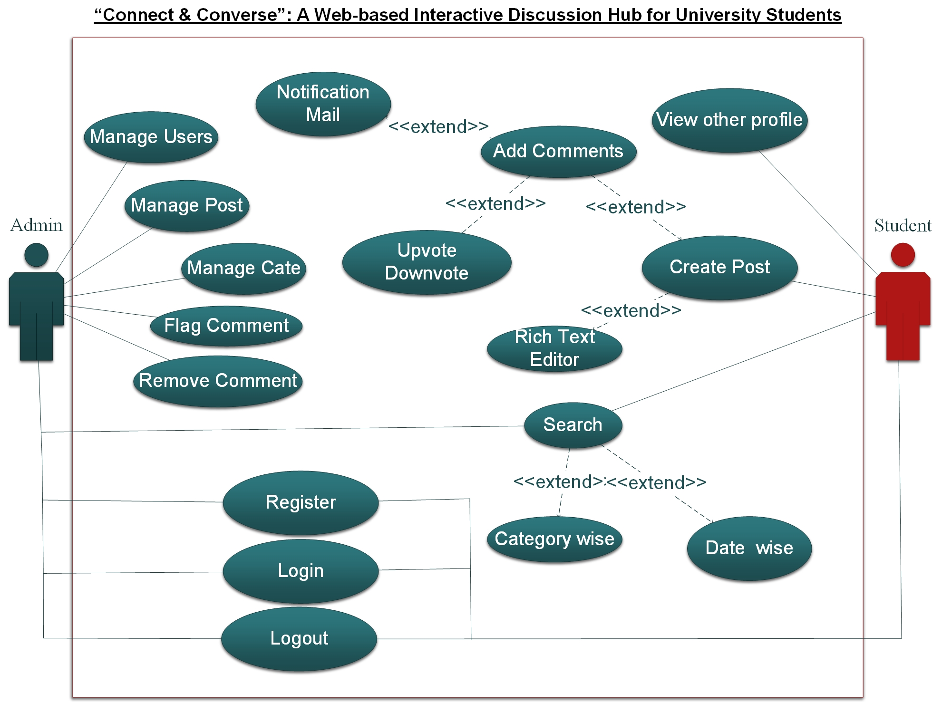

Usage Scenarios:
Usage scenarios outline how a product, service, or technology is applied to meet specific needs or solve problems in real-world contexts. They highlight key users, their goals, and the solution’s impact.
- Usage Scenarios:
Attribute | UC01: User Registration & Login
Actor | User
Use Case ID | UC01
Actions | Register, verify email, log in, recover password.
Description | Secure account creation and login.
Alternative Paths | Skip registration; limited access.
Pre-Conditions | Valid email address.
Post-Conditions | User registered and logged in.
Author | BC210400604
Exceptions | Invalid email/password, server down.
Attribute | UC02: Profile Management
Actor | User
Use Case ID | UC02
Actions | Upload picture, edit bio, view profiles.
Description | Customize profiles and view others.
Alternative Paths | Skip updating profile.
Pre-Conditions | Logged-in user.
Post-Conditions | Updated profile or profile viewed.
Author | BC210400604
Exceptions | Image upload failed, profile not found.
Attribute | UC03: Create Discussion Thread
Actor | User
Use Case ID | UC03
Actions | Add title, description, tags, category.
Description | Initiate discussions on topics.
Alternative Paths | Save draft or cancel creation.
Pre-Conditions | Logged-in user.
Post-Conditions | Thread is created and visible.
Author | BC210400604
Exceptions | Title missing, invalid category, server issue.
Attribute | UC04: Comment on Thread
Actor | User
Use Case ID | UC04
Actions | Comment, reply, upvote, downvote.
Description | Engage with discussions through comments.
Alternative Paths | Edit or delete comments.
Pre-Conditions | Logged-in user viewing a thread.
Post-Conditions | Comment/reply added or updated.
Author | BC210400604
Exceptions | Invalid input, thread locked.
Attribute | UC05: Organize with Categories
Actor | User
Use Case ID | UC05
Actions | Assign category, filter by category.
Description | Group discussions by categories.
Alternative Paths | Search directly instead of using categories.
Pre-Conditions | Predefined categories exist.
Post-Conditions | Threads grouped by category.
Author | BC210400604
Exceptions | Invalid category selected.
Attribute | UC06: Search Posts
Actor | User
Use Case ID | UC06
Actions | Search by keywords, apply filters.
Description | Find posts and users based on keywords.
Alternative Paths | Browse manually without searching.
Pre-Conditions | Threads, posts, or users exist.
Post-Conditions | Search results displayed.
Author | BC210400604
Exceptions | No results, database query fails.
Attribute | UC07: Notifications
Actor | User
Use Case ID | UC07
Actions | Email notifications for interactions.
Description | Notify users about replies and comments.
Alternative Paths | Turn off notifications in settings.
Pre-Conditions | Email notifications enabled.
Post-Conditions | Notifications sent to user.
Author | BC210400604
Exceptions | Email failed, user unsubscribed.
Attribute | UC08: Admin Moderation
Actor | Admin
Use Case ID | UC08
Actions | Flag, review, remove content, manage users.
Description | Ensure safe and organized platform content.
Alternative Paths | Ignore flagged content.
Pre-Conditions | Admin account is active.
Post-Conditions | Content reviewed or removed.
Author | BC210400604
Exceptions | Permissions revoked, flagged content missing.
Attribute | UC09: Rich Text Editor
Actor | User
Use Case ID | UC09
Actions | Format text, attach images, embed links.
Description | Enhance user experience with rich editing.
Alternative Paths | Use plain text instead of formatting.
Pre-Conditions | Logged-in user creating content.
Post-Conditions | Content with formatting saved.
Author | BC210400604
Exceptions | Markdown error, upload failure.
Attribute | UC10: Responsive Design
Actor | System
Use Case ID | UC10
Actions | Access platform across devices.
Description | Accessible interface across devices.
Alternative Paths | Reduced functionality on older devices.
Pre-Conditions | Device with internet connectivity.
Post-Conditions | Interface adapts to screen size.
Author | BC210400604
Exceptions | Poor device compatibility.

Development Methodology:

Chosen Methodology:
Water Fall Model and Spiral Model are two models which are combined to each other and make VU Process Model. It is also called hybrid approach of system development. This Process model takes advantages and minimizes the drawbacks of both approaches. This is a linear model to solve many problems.

Reasons for Chosen Methodology:
Following are the basic reasons for choosing VU Process Model for our project.
- Testing is inherent to every phase
- It is an enforced disciplined approach because to having stage development cycle and every phase has defined start and end date.
- It is documentation driven which means documentation is produced at every stage.
- Emphasis on requirement and design before writing code ensure minimal wastage of time and efforts.
- Our project is divided into different phases which we have to complete in sequence and submit to our supervisor.
- If some mistakes are found than he suggests us to correct those mistakes and improve our project.
- This process will be adopted due to its spiral nature.

VU Process Model:
VU PROCESS MODEL The adopted methodology is VU Process Model which is a combination of Waterfall and Spiral Model.

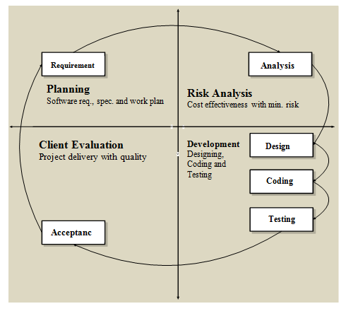

STRUCTURE OF VU PROCESS MODEL:
It has four phases and which are Gathering and analyzing requirement, planning, analysis and design, development and final report

- Gathering & Analyzing Requirement:
In this phase we gathered information regarding functional and non- functional requirements of our Project and also prepared Use case diagrams to understand Actors and Uses cases of project and develop usages scenario diagrams to understand all those situations which will come across while using this application.
- Planning Phase:
In this phase we adopted methodology to complete the project different Phase also prepared the Schedule using Gant chart to know which phase will be completed in how many days.
- Analysis and Design Phase:
In this phase consist of two design documents. In Design document 1, we will develop the Activity Diagram, Sequence diagrams, Collaboration Diagram, Architecture Design Diagram and DFD diagram. And Design document II we develop the Object model, Class diagram, interface design, database design, test cases, Deployment diagram and Component diagram.
- Development & Final Project Report:
In this phase we will write necessary code for implementation of our application. Coding will be completed in iterations.
Spiral Model:
The spiral model is a risk-driven process model generator for software projects. Based on the unique risk patterns of a given project, the spiral model guides a team to adopt elements of one or more process models, such as waterfall. It combines the idea of iterative development with the systematic, controlled aspects of the waterfall model. It is a combination of iterative development process model and sequential linear development model i.e. the waterfall model with a very high emphasis on risk analysis. It allows incremental releases of the product or incremental refinement through each iteration around the spiral

Diagram of Spiral Model:

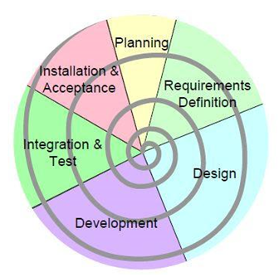

Waterfall Model:
The Waterfall Model was the first Process Model to be introduced. It is also referred to as a linear-sequential life cycle model. It illustrates the software development process in a linear sequential flow. It is very simple to understand and use. In a waterfall model, each phase must be completed before the next phase can begin and there is no overlapping in the phases. The Waterfall model is the earliest SDLC approach that was used for software development.
This means that any phase in the development process begins only if the previous phase is complete. In this waterfall model, the phases do not overlap.
The waterfall model is a sequential (non-iterative) design process, used in software development processes, in which progress is seen as flowing steadily downwards (like a waterfall) through the phases of conception, initiation, analysis, design, construction, testing, production/implementation and maintenance. Despite the development of new software development process models, the Waterfall method is still the dominant process model with over a third of software developers still using it.
This model is depicted in the following diagram.

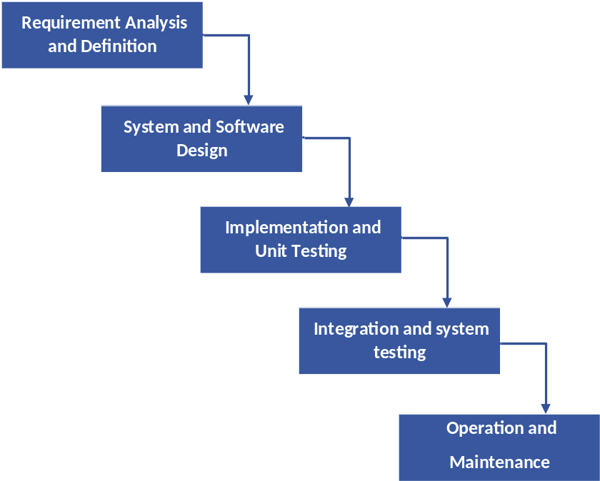

Work Plan (Gantt Chart):
The work plan is a document that consulting firms use to organize a project. It outlines the plan by which the company plans to complete a quality project within a given amount of time and in compliance with a set budget.
Gantt charts are useful tools for planning and scheduling projects. They allow you to assess how long a project should take, determine the resources needed and layout the order in which tasks need to be carried out. They are useful in managing the dependencies between tasks.
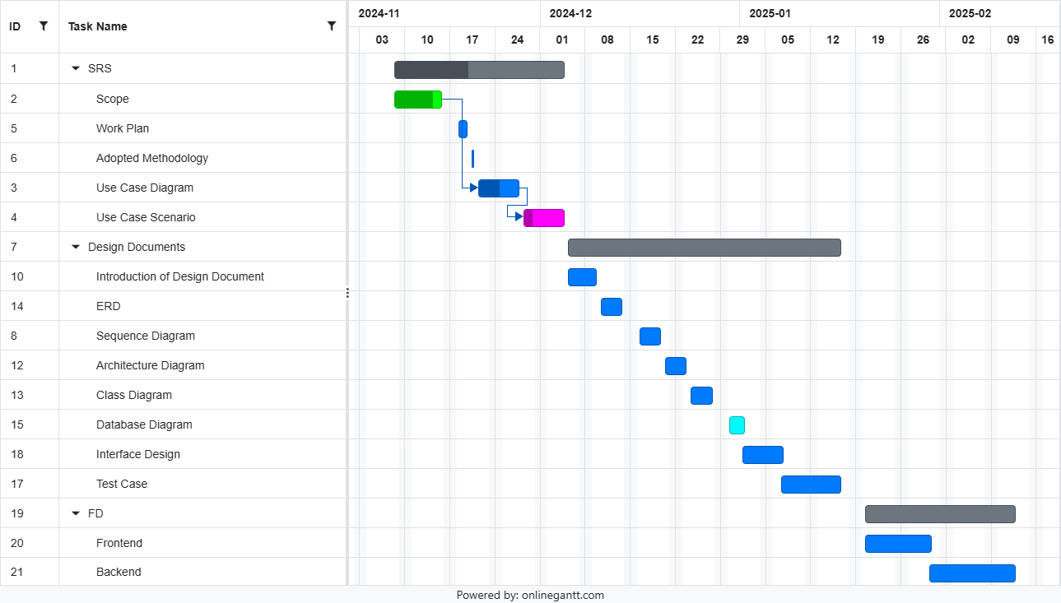

Project Schedule (Submission Calendar):

S No | Task | Start Date | End Date
01 | SRS | Wed 22 Nov, 2023 | Fri 08 Dec, 2023
02 | Design Document | Sat 09 Dec, 2023 | Thu 18 Jan, 2024
03 | Prototype Phase | Fri 19 Jan, 2024 | Thu 29 Feb, 2024
04 | Final Deliverable | Fri 01 Mar, 2024 | Thu 23 May, 2024

Chapter 2

Designing the project

Introduction:
The document provides documentation which will be used to aid in system development. The document provides the details of how the software should be built. The design document includes Entity Relationship Diagram (ERD), Sequence Diagrams, Architecture Design Diagrams, Class Diagram, Database Design, Interface design and Test Cases and other supporting requirement information.

Purpose:
The purpose of software design document is to provide a description of design of system fully enough to allow for software development to proceed with an understanding of what is to be built and how it is expected to build. The software design document provides information necessary to provide description of the details for the software and system to be built.

Scope:
The analysis and design phase in software development process is very important as it provide better management and understanding of the requirements. Additionally, system scope, verification and validation are done in analysis and design. Software quality assurance related planning is done in this phase of project.

Definitions, Acronyms and Abbreviations

• HTML (Hyper Text Markup Language)
• CSS (Cascade Styling Sheet)
• PHP (PHP Hyper Text Markup Language)
• DBMS (Database Management System)
• SQL (Structured Query Language)

ERD
ERD is a diagram that shows the relationships between a group of entities stored in a database. In other words, the ER diagram helps to explain the logical structure of a database. ER diagrams consists of Entities, Attributes, and Relationships. ER diagrams have many shapes like: rectangle shape represent entities, ellipses shape define attributes, and diamond shape represent relationships
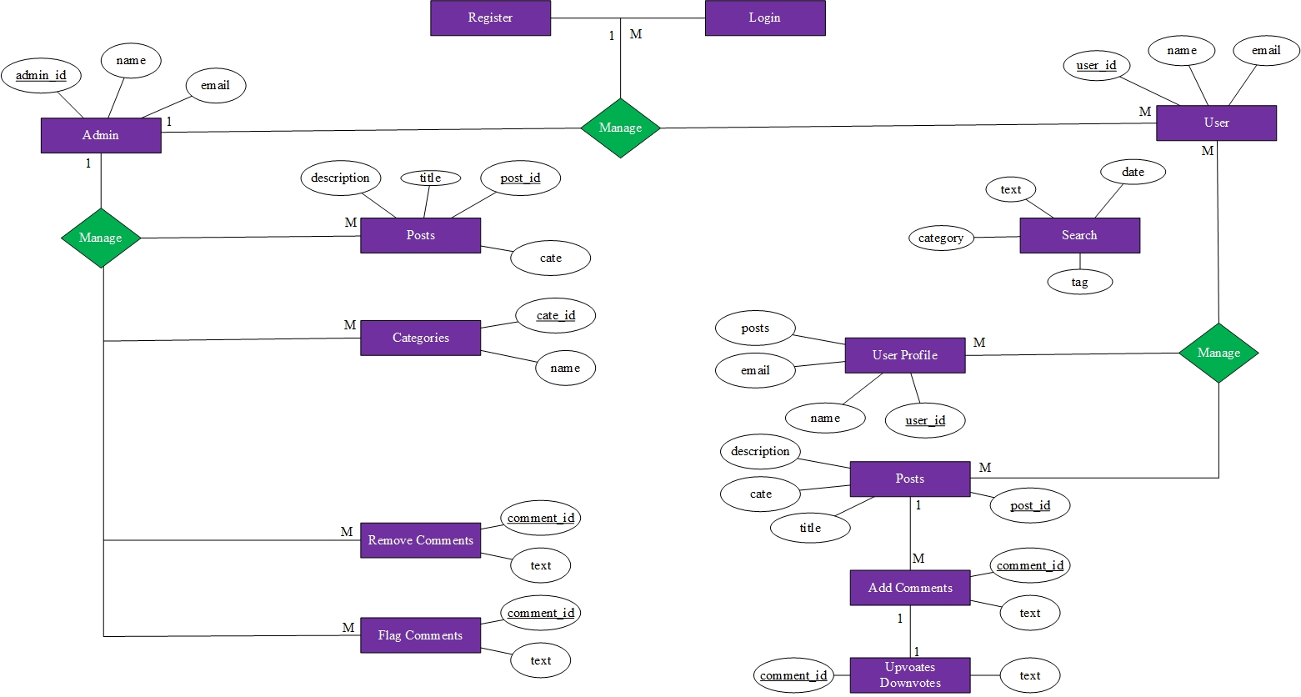

Architectural Representation (Architecture Diagram)
An architecture diagram is a visual representation of the components, relationships, and responsibilities within a software system. It shows the big picture of a software project and outlines the architecture that has been chosen.

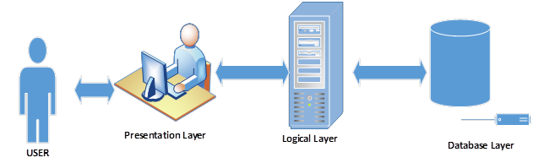

Dynamic Model: Sequence Diagrams:
Sequence diagrams are interaction diagrams that show what messages are sent and when between objects in a system. They are organized by time from top to bottom and by objects from left to right. They are used to represent all the possible interactions in a single-use case. They help to understand how a system achieves a specific goal or function.

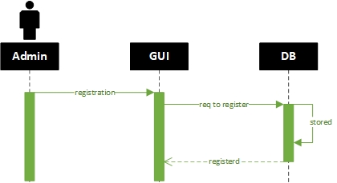
  - Admin Register

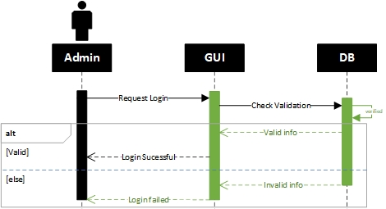
  - Admin Login

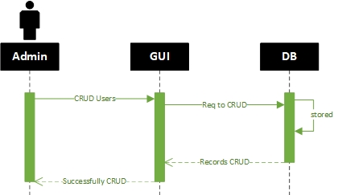
  - Admin CRUD Operations

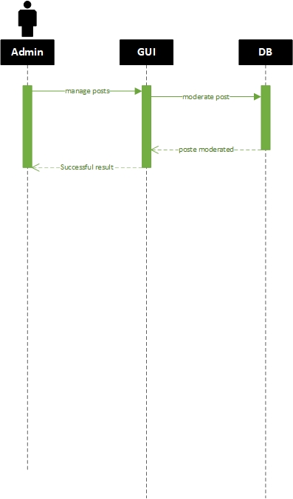
  - Admin Manage Post

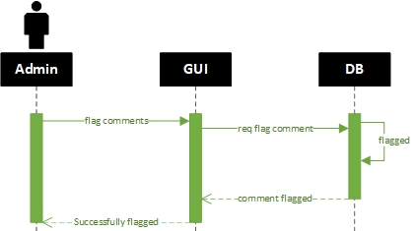
  - Admin Flag Comments

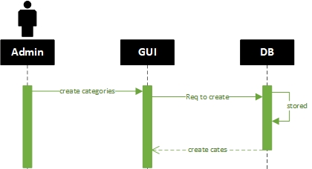
  - Admin Create Category

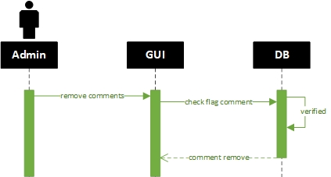
  - Admin Remove Comments

  - Admin Create Tags
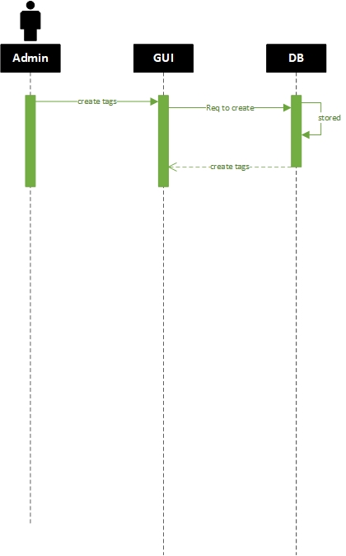

  - User Register
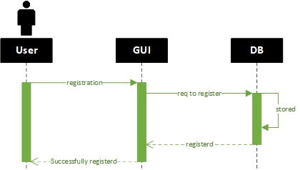

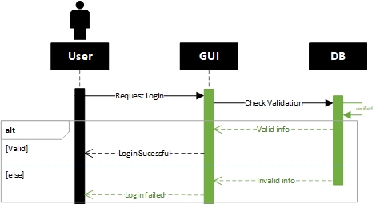
  - User Login

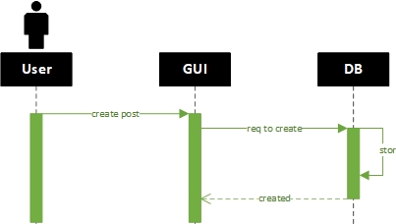
  - User Create Post

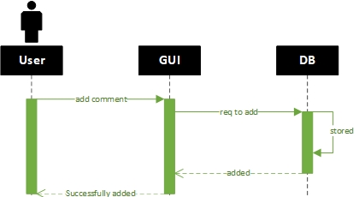
  - User Add Comments

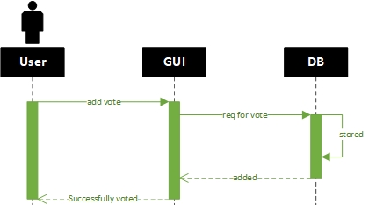
  - User Add Vote

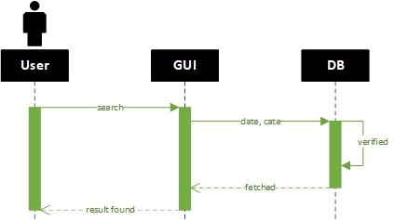
  - User Search Post

Object Model/Logical Model: Class Diagram:
A class diagram is a visual representation of the objects, attributes, and methods in a system. To create a class diagram, you need to identify the classes and their relationships, and use symbols and lines to show them.

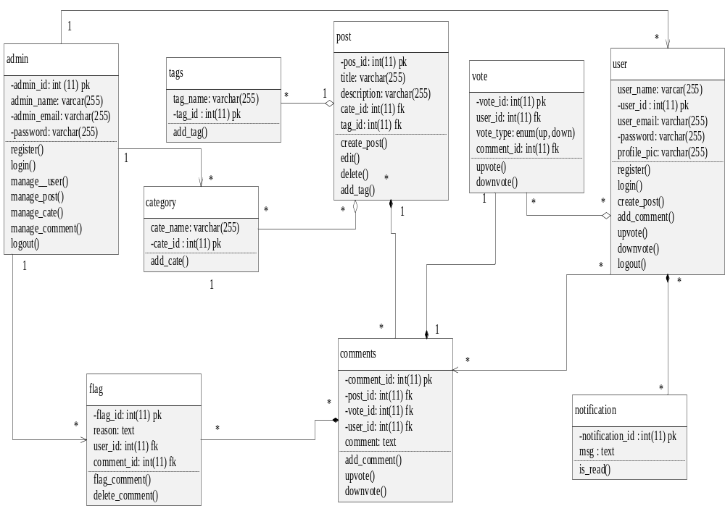

Database Model (Database Diagram):
In a database model, you define the structure of your database, including tables, columns, relationships, and constraints.
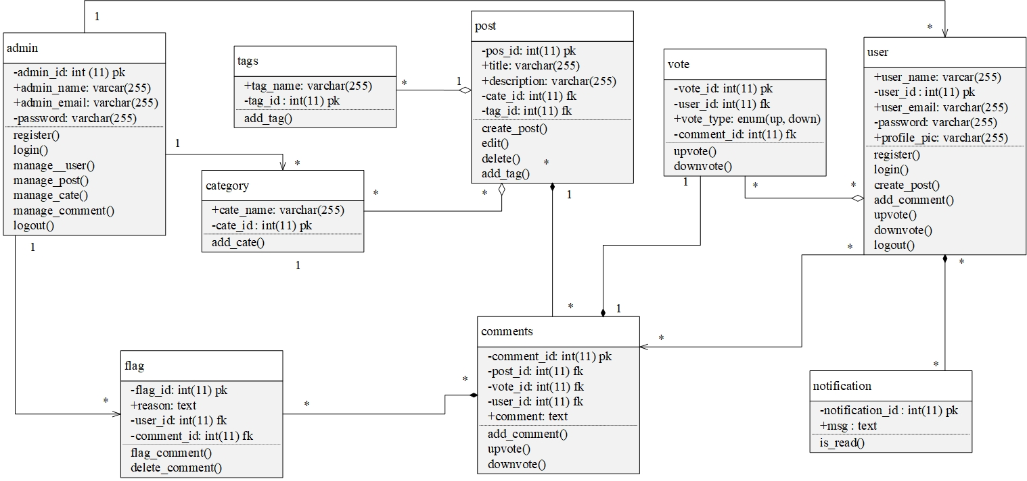

Graphical User Interfaces:
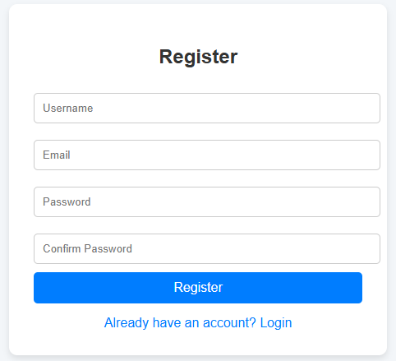

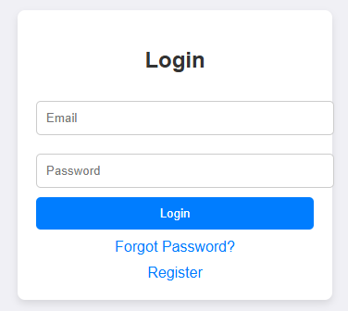

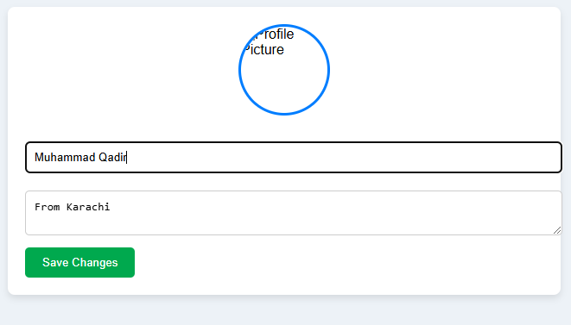

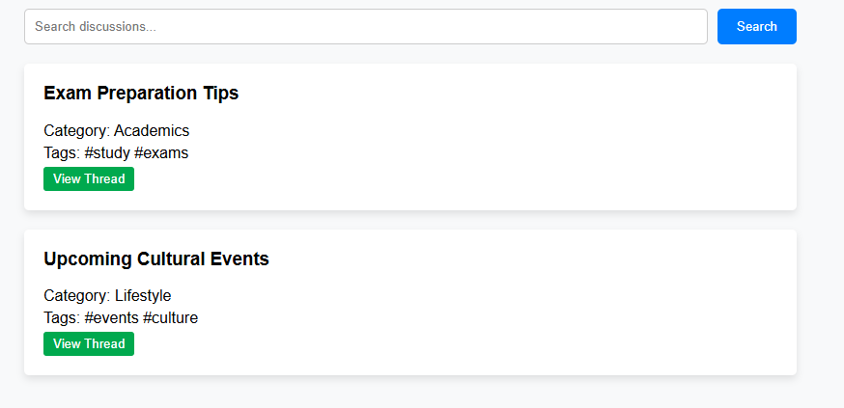

Chapter 3

Development

Development plan (Architecture Diagram)
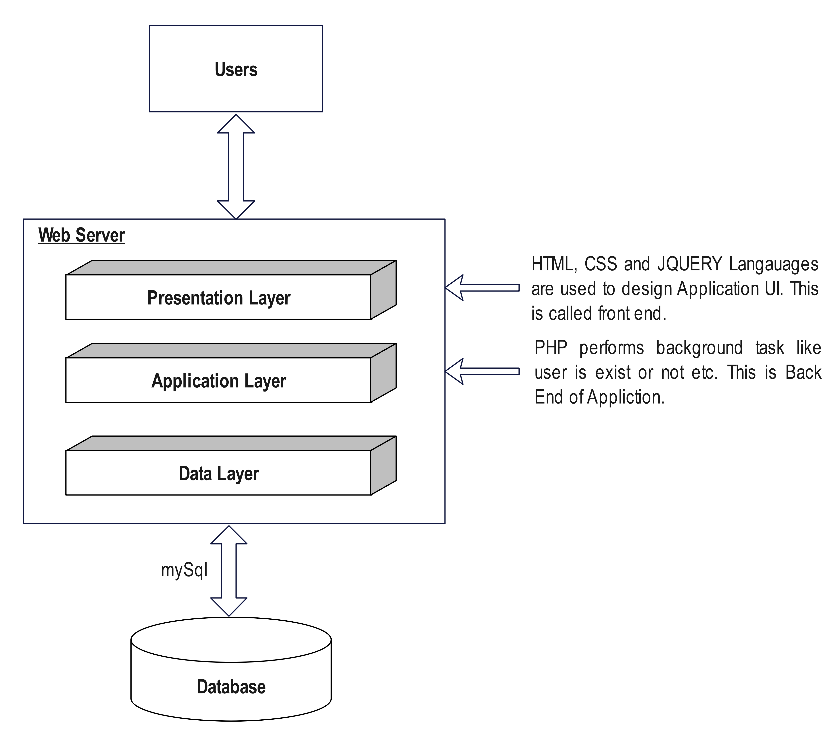

REFERENCES

Handouts CS504 – Software Engineering – I
Handouts CS5605 – Software Engineering – II
Handouts C403 – DMBS

APPENDIX

Section 1 | Gathering & Analyzing Info
Section 2 | Designing the Project
Section 3 | Development

